Model Report

HGV Testing v PSA example
Title of the action

IOW
Court reference number

Final report of Philip Edward Wilson Bsc CEng FICE PPL(FAA) for the AnyCourt

Dated: Dated 26 February 2023

Specialist field: Geotechnical Engineering

On behalf of the Claimant/ HGV & PSA – single joint expert.
Defendant (or both if single
joint expert):

On the instructions of: Bond Solon.

Subject matter: Inadequate Geotechnical Investigation by PSA causing operational and financial loss to HGV Test Division DfT


Phil Wilson Bsc CEng FICE PPL(FAA)
WILGEO Ltd
07985 298874
28 Uwch Y Nant, Mold, CH7 6YP
www.wilgeo.co.uk



Contents
Paragraph number  1 | Paragraph contents  Introduction
2 | The issues addressed and a statement of instructions
3 | My investigation of the facts
4 | My opinion
5 | Statement of compliance
6 | Statement of conflicts
7 | Declaration of Awareness
8 | Statement of truth
Appendices
1 | My experience and qualifications
2 | Experience, qualifications, training of others involved in carrying out any test or experiment
3 | Statement of methodology
4 | List of documents that I have examined, with copies of important extracts
5 | Details of any literature or other material I have relied upon in making this report with copies of important extracts.
6 | Photographs, drawings, schedules, diagrams, graphs and other graphics
7 | Chronology
8 | Glossary of technical terms
9 | Other

Report

1 Introduction

1.01 The writer

I am Philip Edward Wilson Bsc CEng FICE PPL (FAA) and at the time of writing have over 40 years’ experience as a Geotechnical Engineer.

My specialist field is Civil Engineering and within that profession, I am a specialist Geotechnical Engineer, providing advice on geotechnical investigations for foundations of building, structures, motorways, railways and marine facilities including ports and offshore platforms.

Full details of my qualifications and experience entitling me to give expert opinion evidence are in Appendix 1.

1.02 Summary background of the case

The case concerns determining the reasons for obvious structural distortion to an existing HGV testing station, which is causing concern to occupants.

There is a chronology of the key events in Appendix 7. I have been instructed to determine the cause of distress to the building and whether it is related to the foundations.

1.03 Summary of my conclusions

The structure was constructed to a standard design at a wide number of locations across the UK. The structures were supported on simple shallow pad foundations with low bearing pressure and it was decided centrally that a detailed ground investigation was not required at each structure. Whilst slightly controversial, not to undertake a ground investigation, the HGV structures appear to have generally performed satisfactorily.

However, at Kilmarnock, when colliery discard from former coal mining was discovered during construction, it should not have been ignored and additional enquiries should have been undertaken.

My simple investigation of readily available public records has confirmed the presence of a disused mine shaft directly below the centre of the building and is fairly certain to be the cause of obvious distortion to the steel frame of the building. Details of the shaft treatment, if any, are not available and there is potential for collapse, the occupants should cease to use the building immediately.

1.04 Those involved

Those involved in the case are two Government Departments, as follows

- Department for Transport , Heavy Goods Vehicle (HGV) Testing
- Department of Environment, Property Services Agency (PSA)

1.05 Technical terms and explanations

I have indicated any technical terms in bold type. I have defined these terms when first used and included them in a glossary in appendix 8. I have also included in appendix 5 extracts of published works I refer to in my report.

2 The issues to be addressed and a statement of instructions

2.01 The instruction was a simple standard request from PSA Edinburgh office to PSA London office, Directorate of Civil Engineering Services (DCES) to provide geotechnical advice on the possible cause of distress to the HGV building. I worked as a specialist Geotechnical Engineer in DCES and reported directly to PSA/DCES Director and Head of Profession. PSA/DCES London was a central core of specialists with a role to provide advice to regional offices, which did not have the necessary specialist expertise.

3 My investigation of the facts

Basic Facts
Rt Hon Barbara Castle MP was Minister of Transport from 1965 -68 and introduced many initiatives to improve road safety. One initiative was a requirement for regular testing of HGV vehicles; which required the construction of numerous HGV testing stations at locations throughout the UK.
The HGV testing stations were built to a standard design by the Ministry of Building and Public Works (MBPW), the MBPW was the predecessor Government Dept of PSA. HGV stations were required urgently and a standard design was rolled out, based on a simple steel portal frame structure. The lightly loaded, simple structures had a standard shallow foundation design to a relatively low bearing pressure of 50KN/m2. Due to the simple standard design and relatively low bearing pressure, it was not deemed necessary to undertake a Geotechnical Investigation of the sites. The structures included a below ground inspection pit at the centre of the structure to facilitate inspection of the underside of the HGV without the need for a mechanical lifting device.
Rollout across the UK was successful without any major difficulty. At the Kilmarnock site, during construction it was not noted that colliery spoil discard was present and a slightly lower bearing pressure was adopted for the shallow foundations to account for this fill material. However, nobody appeared to have queried how or why colliery spoil was present at the site.
Kilmarnock HGV station operated as intended until the early 1980’s, although HGV test staff had apparently queried apparent visible distortion of the steel structure via their trade unions, but no action was taken.
PSA assumed responsibility for the structure under machinery of government changes and PSA office in Edinburgh were requested by HGV to undertake a structural inspection of the building. A structural engineer from PSA Edinburgh inspected the building, confirmed distortion of the building frame and attributed this to “swelling” of the colliery discard spoil. The particular engineer was known to me from a previous project in Scotland when he had allowed construction of a major new building foundations on peat, without any site investigation. This delayed building occupation whilst a major underpinning project by mini-piling was initiated. I was understandably sceptical of geotechnical opinions from this particular structural engineer.
PSA were organised similar to a private sector consultant with offices in major cities across the UK. The regional offices were serviced for specialist services, such as Geotechnical advice and Investigations, from a central team in London , which I was a member. An internal Works Procedure Code, WPC20, mandated that regional offices must consult with the central geotechnical team

I travelled to Kilmarnock to independently inspect the building; the visible distortion was obvious, but I remained open -minded as to the cause. I spoke with HGV staff and jointly visited the underground inspection pit used to view the underside of vehicles.
I knew from previous experience that local libraries in Scotland held good records of historic OS maps (this pre-dated the common day use of Envirocheck services)
Envirocheck - Environmental reports, mapping products and specialised datasets - Envirocheck Analysis Login
The local library were able to provide a full record of historic OS maps. The maps clearly showed the presence of a former colliery and mine shaft, the location of the mine shaft coincided almost precisely with the HGV inspection pit. More recent maps gradually showed the colliery falling into disuse, closure and recent maps showed a “greenfied site”.
Due to the age of the colliery, little was known about the method used to backfill the shaft, but it was common practice to simple dump old mine wagons into the shaft to form a blockage. This is in contrast to modern day practice which requires a concrete cap at rockhead.
I returned to London with my findings and reported them directly to my Director of Civil Engineering Services.
The HGV station was closed that day and services temporarily located to a local garage. The closure of the HGV station caused HGV operational and financial hardship.
Expert’s Opinion
It was obvious that an adequate site investigation was not undertaken despite clear evidence that there had been previous deep coal mining at the site.

3.01 Assumed facts

I was open minded and simply assumed that the structure had been constructed in accordance with the MPBW drawings but without the benefit of any geotechnical investigation.

3.02 Enquiries/investigation into facts by the expert

As summarised above.

3.03 Documents

The record drawings for the HGV structure were examined.

The crucial documents discovered were the old OS maps held at the local library, which clearly showed the presence of the old colliery and shaft, demolition and abandonment of the colliery, with OS plans from 1960’s (at time of construction) showing a green field site

3.04 Interview and examination

As summarised above, I visited the site to examine the building distortion and interviewed occupants of the building

3.05 Research

My Research was confined to a desk study of historical information as that was sufficient to conclusively demonstrate the cause of building distortion.

In addition, a brief literature review of historical practice into abandonment of disused mine shafts, indicated that at the time of abandonment it was common practice to simply create a blockage in the shaft by dumping old mine tubs. This is in contrast to modern practice which requires construction of a concrete cap at rockhead.

3.06 Measurements tests and experiments etc

Visual inspection of the building only was sufficient to demonstrate historical movement and distortion.

3.07 Facts obtained by others

A structural engineer (without specialist geotechnical knowledge) from PSA Edinburgh office had previously made an independent inspection of the HGV structure and attributed the distortion to swelling of the colliery discard below the building foundations.

This opinion was pure speculation without any survey of the building or swell tests on the soil.

Report of your name
Specialist field your specialist field
On behalf of the Claimant/Defendant name of the party you have been instructed by or
Single Joint Expert

4 My opinion

It was obvious that an adequate site investigation, as required by BS5930, was not undertaken despite clear evidence that there had been previous deep coal mining at the site.
A simple desk study of local records would have revealed the presence of a disused colliery and shaft, this would have explained the discovery of colliery discard at the site during construction, which should not have been ignored so readily

CIVIL PROCEEDINGS

Statement of compliance
I understand my duty as an expert witness is to the court. I have complied with that duty and will continue to comply with it. This report includes all matters relevant to the issues on which my expert evidence is given. I have given details in this report of any matters which might affect the validity of this report. I have addressed this report to the court. I further understand that my duty to the court overrides any obligation to the party from whom I received instructions.

Declaration of Awareness
I confirm that I am aware of the requirements of Part 35 and Practice Direction 35, and the Guidance for the Instruction of Experts in Civil Claims 2014.

Statement of conflicts
I confirm that I have no conflict of interest of any kind, other than any which I have already set out in this report. I do not consider that any interest which I have disclosed affects my suitability to give expert evidence on any issue on which I have given evidence and I will advise the party by whom I am instructed if, between the date of this report and the trial, there is any change in circumstances which affects this statement.

Statement of truth
I confirm that I have made clear which facts and matters referred to in this report are within my own knowledge and which are not. Those that are within my own knowledge I confirm to be true. The opinions I have expressed represent my true and complete professional opinions on the matters to which they refer.
I understand that proceedings for contempt of court may be brought against anyone who makes, or causes to be made, a false statement in a document verified by a statement of truth without an honest belief in its truth.

Signature....PEWilson.........................Date.26 February 2023

APPENDIX 1

My Experience and Qualifications

Refer to attached CV and details of Expert Witness experience on company website www.wilgeo.co.uk

APPENDIX 2

Experience, Qualification and Training of Others involved in carrying out any test or experiment

Generally not applicable as assessment was based purely on visual examination of the building and records by myself.

APPENDIX 3

Statement of methodology

Expert opinion is based solely on visual examination of the building and records by myself, as stated above.

APPENDIX 4

List of documents Examined

Record drawings of “as built” structure together with inspection of all available historical OS maps of the building location.

APPENDIX 5

Details of literature or any other material examined (extract below)

British Standard BS 5930 includes a clear requirement to undertake a desk study of previous site use.

BS 5930:2015 Code of practice for ground investigations

Annex B. General information for a desk study | bs5930-2015 (geotechnicaldesign.info)

Extract from Annex B BS5930
d)tunnels; mine workings, abandoned, active and proposed, mineral rights and ownership, and authorizations/permits to work (e.g. Network Rail and the Coal Authority);

APPENDIX 6

Photos, Drawings etc

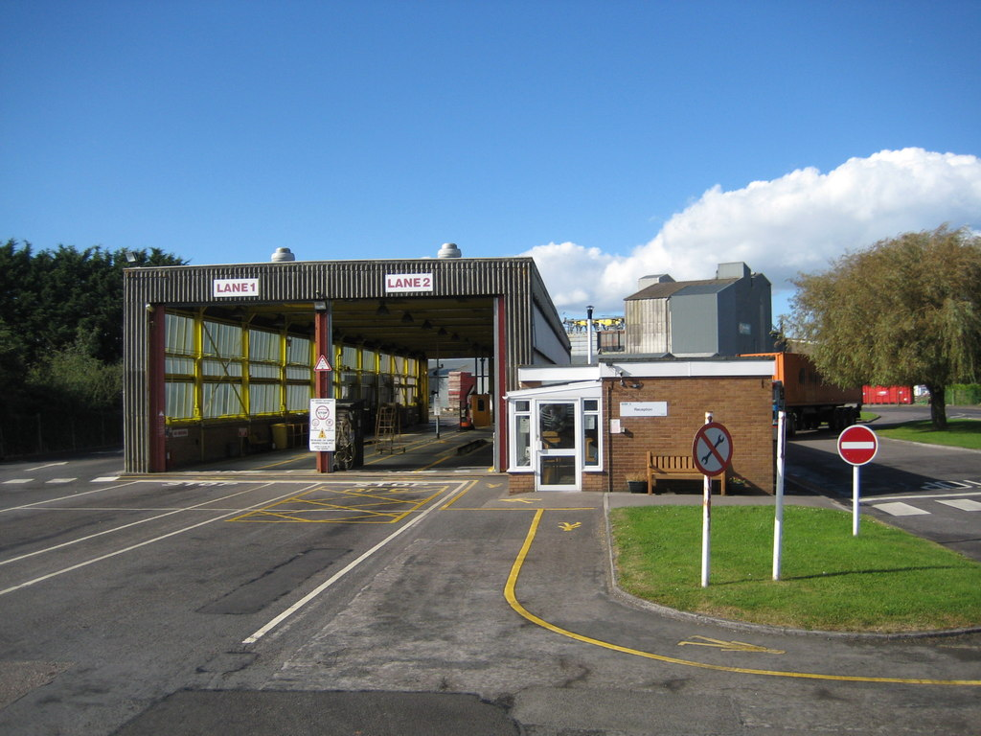

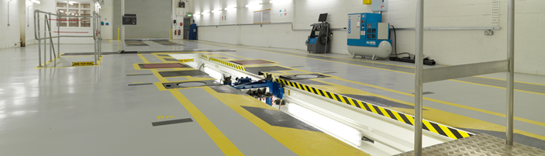

Typical HGV Testing Station, with lightweight portal frame and below ground inspection pit

APPENDIX 7

Brief Chronology

As outlined in report, building construction to a standard design in 1960;s followed by discovery of cause of distortion by expert in 1980’s.

APPENDIX 8

Glossary

Portal Frame – simple lightweight steel structure, commonly used for industrial buildings

Allowable Bearing Pressure – the safe foundation pressure that can be applied to the soil without causing excessive settlement.

Colliery Discard – a waste material by product from the extraction of coal by deep mining.

